RFP Draft

Project:

Capay Valley Fire Protection District is soliciting proposals for the demolition of an existing 32’x40’ 1968 Butler Building, and the construction of a new 40’x50’ steel building in its place.

Existing Structure:

CVFPD parcel is 0.27 acres. The existing building is oriented roughly north/south parallel to Highway 16 with an electrical panel on the exterior of the building on the NW corner. The building is a steel construction butler building with no active water or sewer, however at one time the building was plumbed to a well and a septic tank on the adjacent property. Pipes are still in place. The building is less than 10’ from the N property line, approximately 30’ from the S property line, approximately 40’ from the E property line and 40’-45’ from the Highway. There are two 10’ tall automatic roll up doors facing the highway and a man door facing the highway on the SW corner. The building contains a small kitchenette and bathroom of 2x4 construction. Electrical service to the building is active. See photos in Exhibit A

Demolition:

The electrical service shall be disconnected, or if continued electrical service is desirable during demolition and construction, it may be relocated temporarily in accordance with all applicable codes. The building shall be dismantled or destroyed – whichever method is most cost-effective. All material from the existing structure shall be removed from the property by the contractor or their designee as part of the project. The exception to this demolition shall be the current slab, which shall be retained as completely as possible, and incorporated into the new foundation design for the new building, except in places where material needs to be removed to accommodate the new foundation. Demolition will include removal of any existing debris or vegetation on the property which will impede construction, and will include removal of roof mounted antenna, as well as an unused power pole behind the building.

New Structure:

CVFPD is building a 40’x50’ steel building, with the roof ridge running N/S parallel to the highway. This building is classified as a “fire station” and must meet all appropriate seismic standards for this designation. Roof pitch shall be 2/12 and gutters shall be installed.

The building needs to be constructed at least 10’ from existing property lines. Placement of the building shall maximize the preservation and use of the existing slab, which will not be removed except where necessary to accommodate the new foundation plan. See diagram in Exhibit B.

Windows and Doors:

The building shall be equipped with 2 roll up doors, 14 ft. high and 12 ft. wide openings. These doors shall be equipped with appropriate safety sensors at ground level as well as manual override in event of power outages. These doors shall also have a keypad installed on the exterior of the building, one for each door located on the right side of the door.

The building shall be equipped with 2 hollow core steel exit doors, operated from inside by push bars, and operated from the outside by keypad combination locking door handles.

The building shall include 3 windows, 2 of them 4x4 and one of them 3x4. Specific placement of exit doors, windows, and rollup doors included in Exhibit C. Measurements are as follows:

East side of building:

1. One 36” man door 9.5’ on center from SE corner
2. One 4x4 window 3.5’ on center from SE corner

South side of building:

1. On e 4x4 window 15’ on center from SE corner

West side of building:

1. One 12’ W, 14’ H roll up door 30’ on center from SW corner
2. One 12’W, 14’ H roll up door 22’ on center from SW corner
3. One 3’ W, 4’ H window 8’ on center from SW corner
4. One 36” man door 3’ on center from SW corner

Lighting:

Interior lighting should be provided with two banks of 6 LED shop light fixtures centered on the apparatus bay doors and running across the interior of the building. Light switches shall be located next to each man door, as well as one switch for each roll up door located roughly behind the exterior keypad opener for each door.

Additional lighting shall be provided by translucent roof panels evenly spaced across the roof, 3 on each side of the ridge.

Exterior lighting shall consist of 3 waterproof LED fixtures oriented around the roll up doors, one on each side and one in the middle. There shall be additional fixtures above each man door for a total of 5 exterior lights.

Electrical:

A new main panel shall be installed, equipped with the necessary transfer switch for an automatic whole-house-generator. All wiring in the building shall be in EMT.

Generator:

A whole house generator shall be installed. The fuel source shall be propane. The generator shall be automatic, self-testing, as quiet as possible, and capable of providing sufficient electricity to fully run the station. The propane tank and generator shall be positioned ????

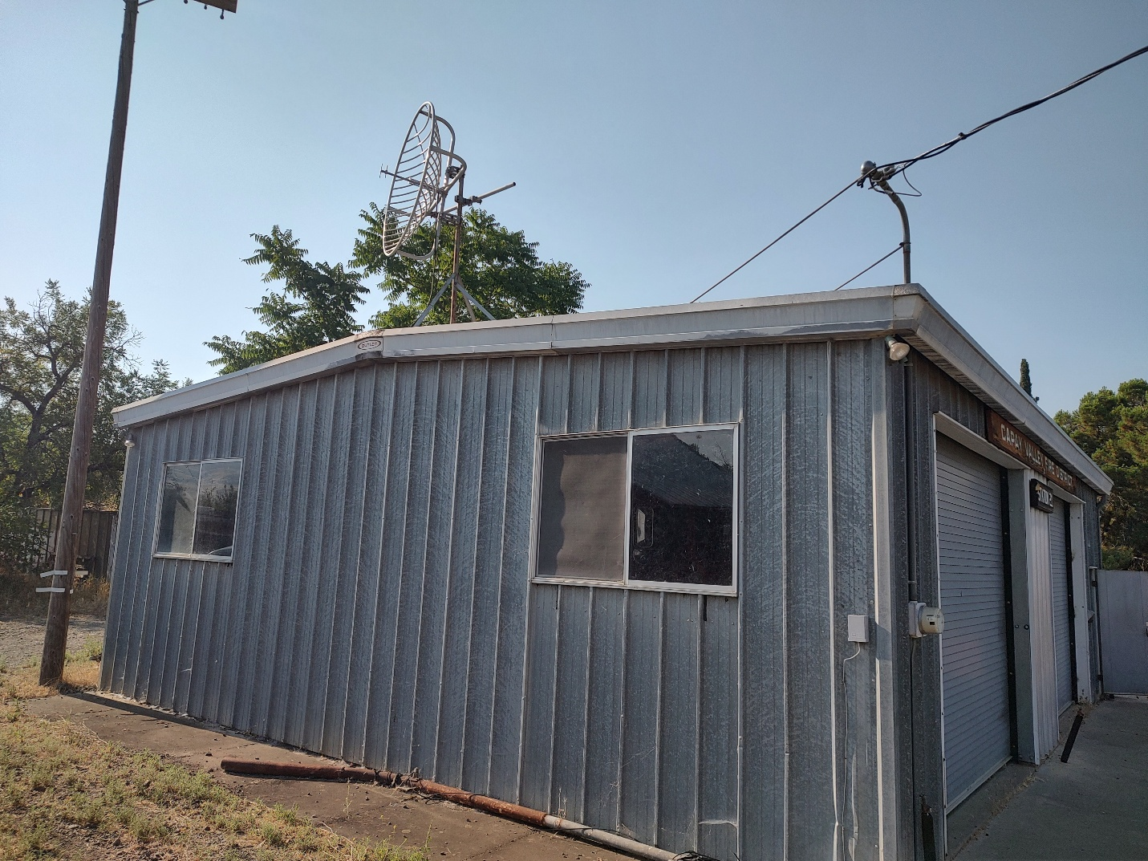

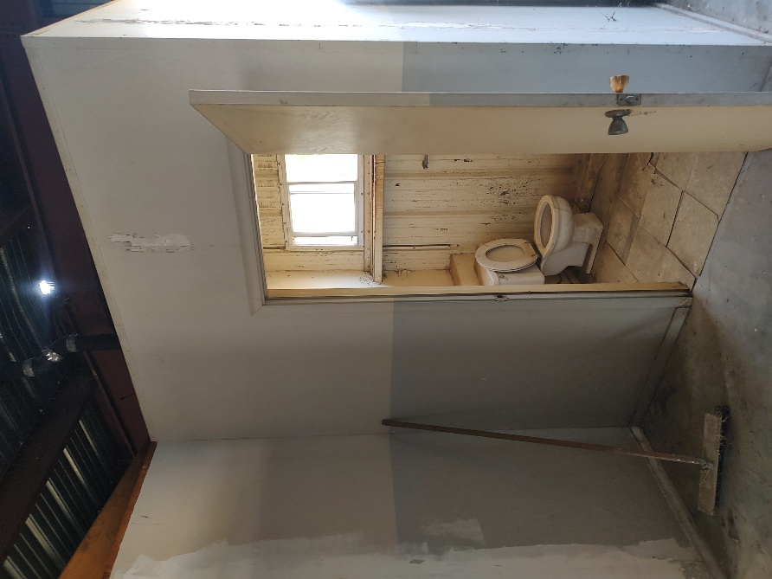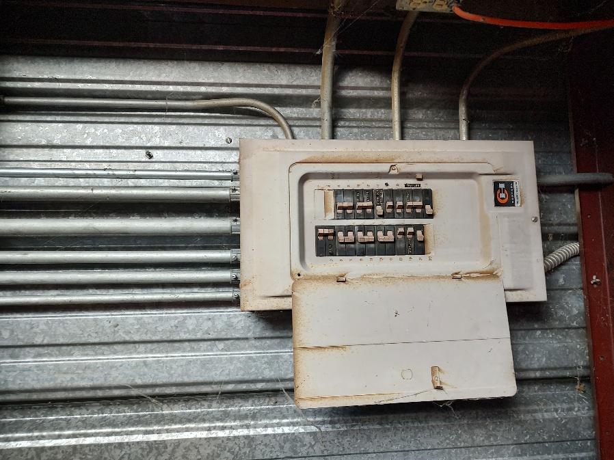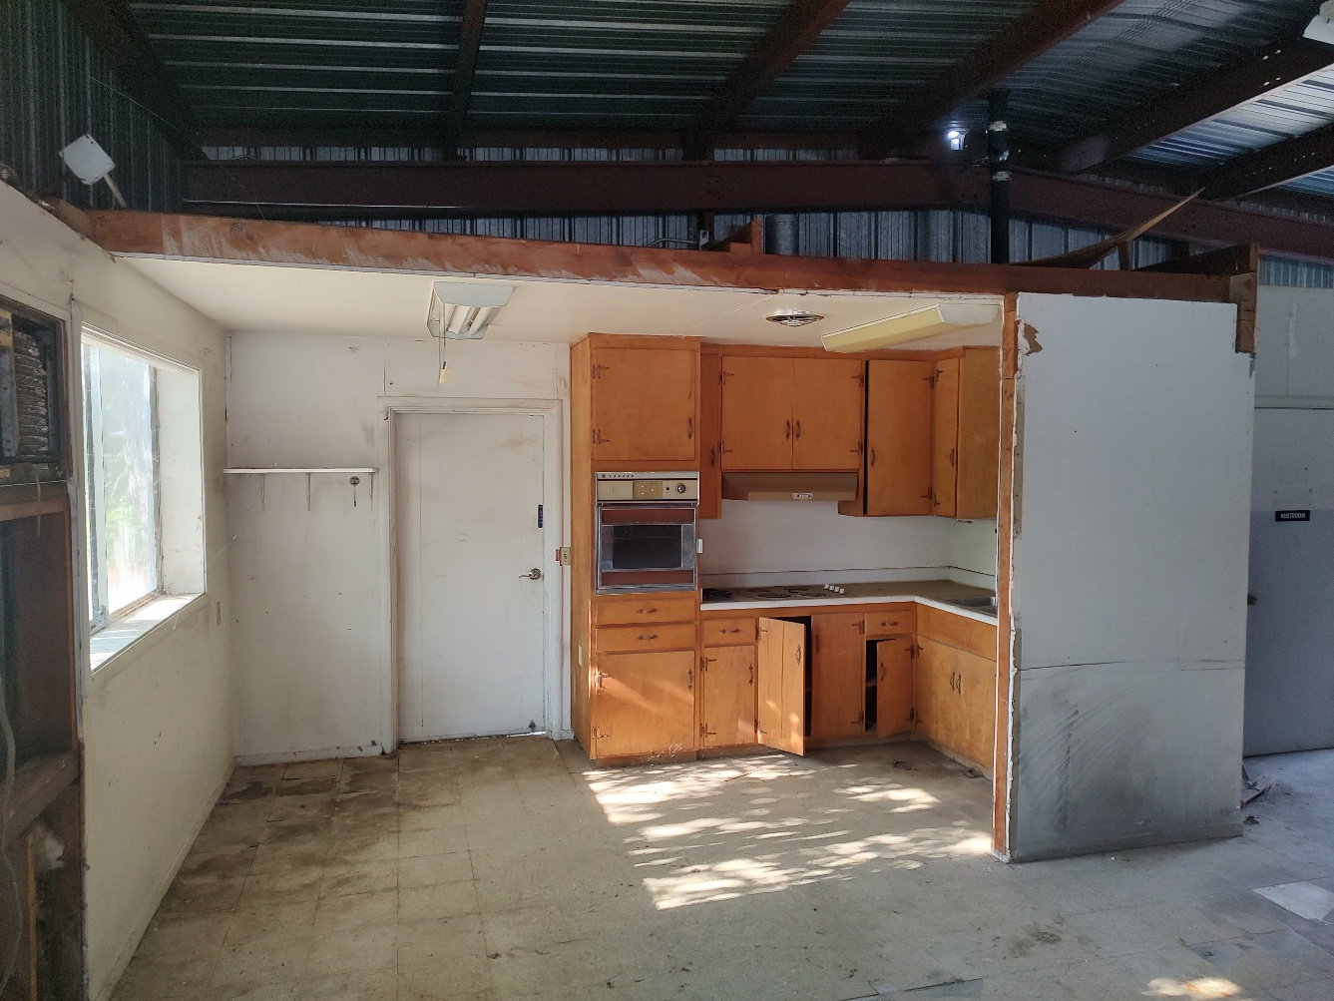

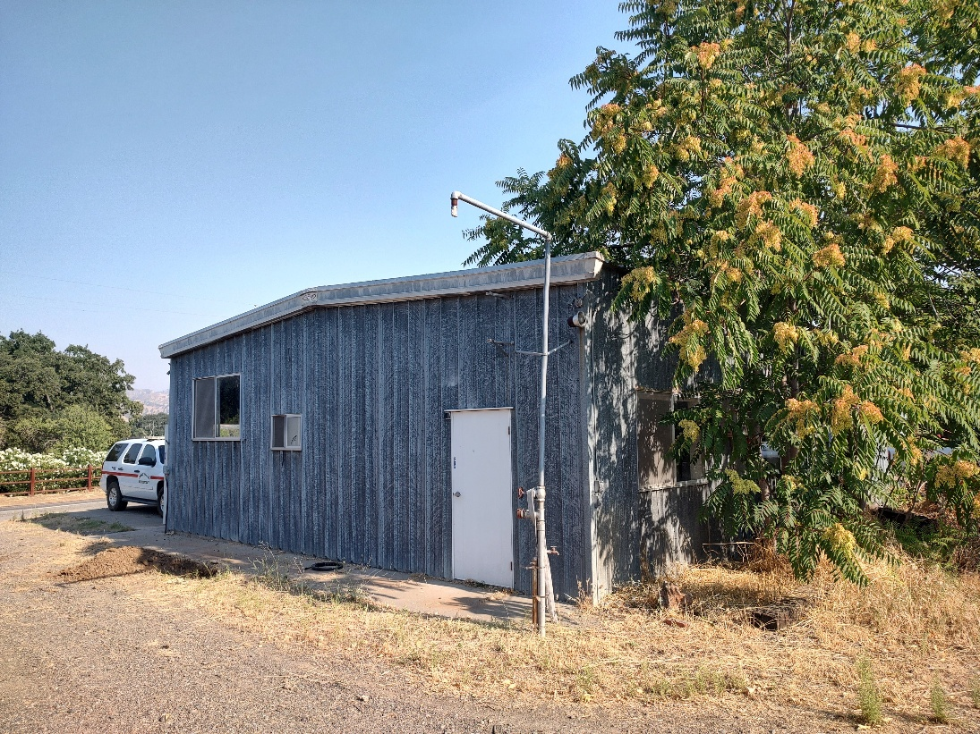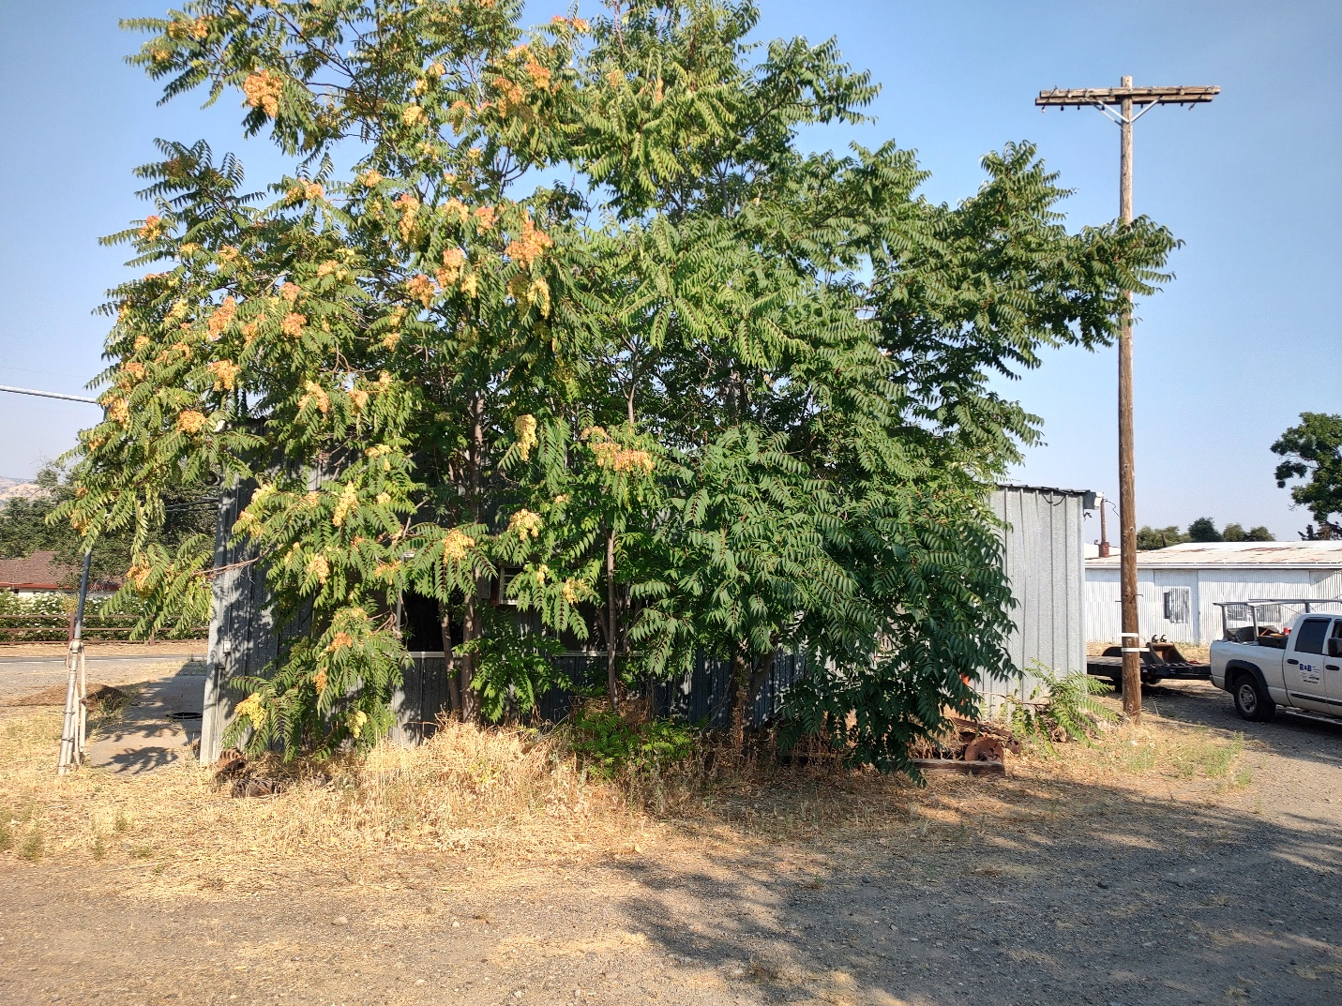

Exhibit A photos in order of appearance:

1. West facing side of building (front)
2. North facing side of building showing weatherhead and disused antenna and power pole.
3. Non-functioning bathroom
4. Main electrical panel
5. Kitchen buildout
6. South Facing side of building – disused overhead engine fill
7. East Facing side of building – trees of heaven.

Exhibit B – Overlay

Property boundary and footprint of existing building in red, proposed approximate position of new structure in blue.

